4th Grade November Newsletter
Mrs. McCarty’s Class News
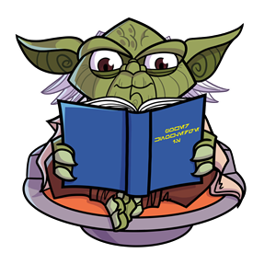

Upcoming Events

November 7
YPC Field Trip 10:00-12:00

November 7
PTO Meeting 5:00

November 8
iRoar Assembly 1:35

November 8
Choices Fair 5:30-8

November 10
No School- Veterans Day

November 17
Picture Retakes

November 17
4th grade health video
November 20-24
No School- Fall Break
= = = = = = = = = = = = = = =
For homework help, or links to online games we use in class, check out www.collegehill4thgrade.weebly.com
For pictures and updates in our classroom, check out https://www.facebook.com/groups/mccarty4th/

Specials Schedules
Monday- Science/Library
Tuesday- PE/Music
Wednesday- PD(various)
Thursday- PE/Science
Friday- Art/Music

Dear families,
Thank you so much for attending your child’s conference. I am looking forward to seeing growth this quarter! I also want to say a huge thank you for how our 4th grade Halloween party turned out. I appreciated all of the snacks and I know the students loved them too!
-Mrs. McCarty

English Language Arts: The theme for Unit 3 is “ideas” and how they lead to new learning, accomplishments and inventions. The focus will be on opinion writing. We will also work on mastering parts of speech and structures of sentences.
Math: We are still working on Module 3, all about multiplication. We are working on mastering our multiplication facts here at school, but your student will probably need to practice more at home too. They can memorize their facts like normal (example, 6 x 4 = 24) or they can work on perfecting their multiples memorization to help problem solve through the facts (example 6x4=? 4, 8, 12, 16, 20, 24)
Science: We finished up our unit on sound waves and are almost finished with our unit on natural resources and the water cycle. Now we will focus more on rocks and changing landforms

